Technical data sheet
Duchesse Potatoes

A. PRODUCT

Duchesse Potatoes - prefried and frozen
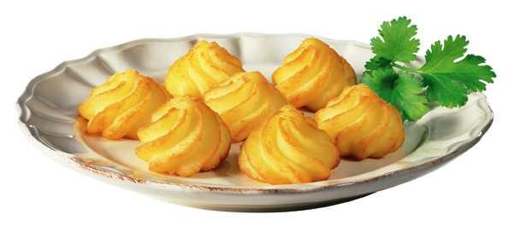
B. SPECIFICATIONS

1°) Processing

The Duchesse Potatoes are produced from yellow flesh potato tubers, « Bintje » variety. (*)

The potatoes are washed, steam-peeled and cut into slices. The potato slices undergo a blanching process for several minutes at a temperature of 70°C to 85°C and a cooling process before being steam cooked.

After cooking, the slices are mashed using a process that allows the removal of the maximum amount of defects. Emulsifier E471 is added for a good stabilisation of the end product.

The following ingredients are then added and mixed: potato flakes, skimmed milk powder, salt, spices, stabiliser E464. The Duchesse Potatoes are then formed from the mash mixture and prefried in non-hydrogenated vegetable oil at 160°C for ± 2 minutes. They are then deepfrozen at - 30°C, packed and stored at a temperature of –20°C.

(*) Except between main crop seasons or in the event of circumstances beyond our control.

2°) Quality control

a) Raw material: Upon arrival at the factory, the potatoes undergo controls including variety, percentage of dry matter, reducing sugars, etc... A good quality raw material is the basis of each production.

b) During the production process:

-Bacteriological control:
During and after production, our laboratory carries out all the necessary bacteriological tests in order to guarantee the best quality.

- Physico-chemical control:
During the whole production process the quantity of the different ingredients are controlled.
Each packaging line is equipped with a metal detector.
The dry matter and the salt content of end product are measured as well as the quantity of physical defects (black spots, misshapen products…) and coloration faults.

- Organoleptic control:
Different tests are carried out in order to control appearance, colour, taste and texture of the end product. After final cooking the Duchesse Potato must have a golden colour.

C. INGREDIENTS

Mashed potatoes, potato flakes, vegetable oil, skimmed milk powder, salt, emulsifier E471, stabiliser E464, spices, antioxidant: metabisulphite.
Contains derivatives of milk and metabisulphite.
May contain traces peanuts.
Manufactured in a factory where traces of the following may be present: wheat, eggs, soya and celery.

D. COOKING INSTRUCTIONS

Household preparation

Cook from frozen.

In the fryer:
Half-fill the basket with the Duchesse Potatoes. Fry them in hot oil at 175°C for about 4-5 minutes. Drain and serve immediately.

In the oven(*):
Pre-heat the oven to 200°C. Spread the Duchesse Potatoes on a baking tray. Place in the middle of the oven and bake for about 12 to 15 minutes.

(*) Cooking times can vary slightly according to the type of your oven

Professional preparation

Cook from frozen

In the fryer: 3 to 4 minutes at 175°C

In the oven (*) : for about 10 minutes at 200°C.

(*) Cooking times can be different depending on the power of your oven and the amount that you want to cook.

E. STORAGE

1°) Transport - storage

Always at a temperature of - 18°C.

2°) Storage (in accordance with the instructions on the packaging):

In star-marked frozen food compartment of a refrigerator * (- 6°C): 1 week;
or in a freezer *** (- 18°C): several months, without going past the best before date.

Do not refreeze once thawed.

3°) Expiry date

We recommend that the product is consumed within 24 months after production date.

F. CODING PRODUCTION DATE - EXPIRY DATE

1°) Production date (lot n°): e.g. L21020723

Composed of 8 digits. From left to right:
Number 2 indicating the production year e.g. 2 for 2002
Number 102: production day
Number 07: packing machine
Number 23: packing hour

2°) Expiry date:

24 months after production date indicated by the month and the year, e.g. 03.2004.

G. ANALYTICAL SPECIFICATIONS

Duchesse Potatoes - prefried and frozen

CHEMICAL ANALYSES  Dry matter  Fat content  Free fatty acids | _  x: 31,5%, min. 29,5 %  _  x: 5,5%  1,5% max.
NUTRITIONAL VALUE PER 100 GR OF FROZEN PRODUCT  kcal  kJ  Protein  Carbohydrate  Total fat | 143,5 kcal  603 kJ  2,5 g  21,- g  5,5 g
MICROBIOLOGICAL ANALYSES
m* M*
Total plate count : 10 000/g 100 000/g
Yeasts : 200/g 2 000/g
Moulds : 200/g 2 000/g
Coliforms : 100/g 1 000/g
Staphylococcus aureus : 100/g
VISUAL QUALITY  Average weight per Pom’ Duchesse  Average diameter  Average height | 17,- g  40 mm  30 mm

