Technical data sheet
Potato Noisettes (± 6 g)

A. PRODUCT

Potato Noisettes - prefried and frozen
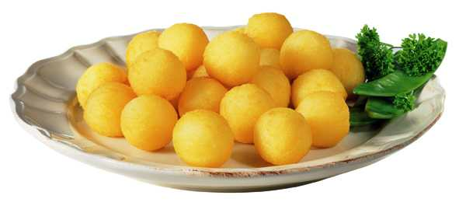

B. SPECIFICATIONS

1°) Processing

The Potato Noisettes are produced from yellow flesh potato tubers, « Bintje » variety (*).

The potatoes are washed, steam-peeled and cut into slices.
The potato slices undergo a blanching process for several minutes at a temperature of 70°C to 85°C and a cooling process before being steam cooked.

After cooking, the slices are mashed using a process that allows the removal of the maximum amount of defects. Emulsifier E471 is added for a good stabilisation of the end product.
The following ingredients are then added and mixed: potato flakes, skimmed milk powder, salt, spices and stabiliser E464.

The Potato Noisettes are then formed from that mash and then prefried in non-hydrogenated vegetable oil at 160°C for ± 2 minutes. Then they are deepfrozen at - 30°C, packed and stored at a temperature of - 20°C.

(*) Except between main crop seasons or in the event of circumstances beyond our control.

2°) Quality control

a) Raw material: Upon arrival at the factory, the potatoes undergo controls including variety, percentage of dry matter, reducing sugars, etc... A good quality raw material is the basis of each production.

b) During the production process:

- Bacteriological control:
During and after production, our laboratory carries out all the necessary bacteriological tests in order to guarantee the best quality.

- Physico-chemical control:
During the whole production process the quantity of the different ingredients are controlled. Each packaging line is equipped with a metal detector. The dry matter and the salt content of end product are measured as well as the quantity of physical defects (black spots, misshapen products…) and coloration faults.

- Organoleptic control:
Different tests are carried out in order to control the appearance, colour, taste and texture of the end product. After final cooking Potato Noisettes must have a golden colour.

C. INGREDIENTS

Mashed potatoes, potato flakes, vegetable oil, skimmed milk powder, salt, emulsifier E471, stabiliser E464, spices, antioxidant: metabisulphite.
Contains derivatives of milk and metabisulphite.
May contain traces of peanuts.
Manufactured in a factory, where traces of the following may be present: wheat, eggs, soya and celery.

D. COOKING INSTRUCTIONS

Household preparation

Cook from frozen

In the fryer:
Heat the oil to 175°C. Half-fill the basket with the Potato Noisettes. Fry them for about 3-4 minutes. Halfway through cooking, shake the basket, without removing it from the fryer. Drain and serve immediately.

Before frying again, please ensure that the temperature of the oil has reached 175°C.

In the oven (*):
Pre-heat the oven to 200°C. Spread the Potato Noisettes on a baking tray. Place in the middle of the oven and bake for about 10 minutes, turning them regularly.

Under the grill of the oven (*):
Same, but cook for 8 minutes.

(*) Cooking times can vary slightly according to the type of your oven.

In the frying pan:
Heat a little oil and fry the Potato Noisettes for 5 to 7 minutes on a medium heat, shaking the pan occasionally.

Professional preparation

Cook from frozen

In the fryer: 2 to 3 minutes at 175°C

In the oven (*) : for about 10 minutes at 200°C.

(*) Cooking times can be different depending on the power of your oven and the amount that you want to cook.

E. STORAGE

1°) Transport - storage

Always at a temperature of - 18°C.

2°) Storage (in accordance with the instructions on the packaging):

In star-marked frozen food compartment of a refrigerator * (- 6°C): 1 week ;
In a freezer *** (- 18°C): several months, without going past the best before date.

Do not refreeze once thawed.

3°) Expiry date

We recommend that the product is consumed within 24 months after production date.

F. CODING PRODUCTION DATE - EXPIRY DATE

1°) Production date (lot n°): e.g. 21022123

Composed of 8 digits. From left to right:
Number 2 indicating the production year e.g. 2 for 2002
Number 102: production day
Number 21: code of packing machine
Number 23: hour of packing

2°) Expiry date:

24 months after production date indicated by the month and the year, e.g. 12.2004.

G. ANALYTICAL SPECIFICATIONS

Potato Noisettes - prefried and frozen

CHEMICAL ANALYSES  Dry matter  Fat content  Free fatty acids | _  x: 40 %, min. 38 %  _  x: 6 %  max. 1,5 %
NUTRITIONAL VALUE PER 100 GR OF FROZEN PRODUCT  kcal  kJ  Protein  Carbohydrate  Total fat | 180 kcal  757,5 kJ  3,5 g  28,- g  6,- g
MICROBIOLOGICAL ANALYSES
m* M*
Total plate count : 10 000/g 100 000/g
Yeasts : 200/g 2 000/g
Moulds : 200/g 2 000/g
Coliforms : 100/g 1 000/g
Staphylococcus aureus : 100/g
VISUAL QUALITY  Average weight per Potato Noisette  Average diameter | 6,- g  25 mm

